Donna Yanew

ED 558

Dr. Carroll

December 6, 2013

Fact Checking

McClellan financial publication November 27, 2013, (http://www.mcoscillator.com/learning_center/weekly_chart/1929_analog/)

posted an article regarding the similar trends of the stock market today and the stock market in 1928 and1929. He uses a chart created by Tom DeMark depicting the similarities in these trends and basis his forecast of the American economy on the similarities represented in the given chart. The interesting and misleading information given in this research is how the chart is represented. The y- axis for the 1928-29 line on the right side of the chart uses a much different scale from the axis that is used to represent today. By doing this it would appear that today’s stock market is on the same path as the stock market in 1929 and America should brace itself for great trouble.

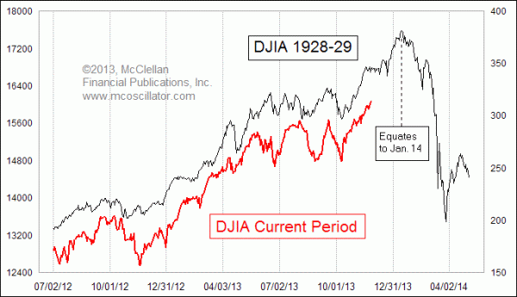

When an audience looks at this chart what they see is a definite parallel, and history is repeating itself. The stock market prices on the left do represent the prices of today, but the scale used is so significantly different than the one represented for the 1929 stock market, which makes the trend seem close to identical.

However, when the charts are put on the same scale the results show differently. Here the story may not seem as dire. This is not to say that the economy isn’t in trouble, rather it is to say that the graph, representing the research is misleading.

Graph 2, using the same scale:

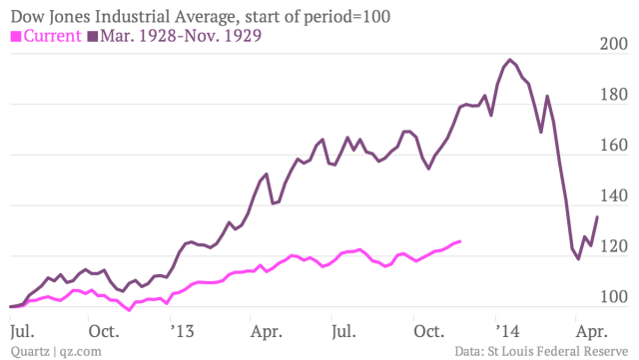

The method of representing the findings is skewed and therefore misleading and not good research practice. This is also to say that when a news group or individual wants to report on findings they aught to do their homework if they truly want to be credible. The original report given